1. Write a program that asks the user to type a word and return him its reverse without using any predefined function . Example if the user enters the word python, the program returns nohtyp to him as shown in the figure below:

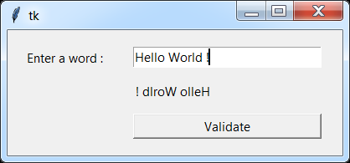

2. Create a graphical application in Python Tkinter that asks the user to enter an integer N and displays them the value of the sum "1 + 2 + ... + N" as shown in the figure below:

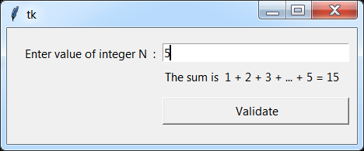

3. Write a program in Python that displays a window to the user that asks them to enter an integer N and displays its factorial N !, as shown in the figure below:

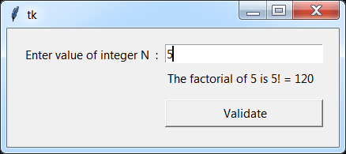

4. Create a graphical application in Python Tkinter that asks the user to enter two integers and displays their sum as shown in the figure below:

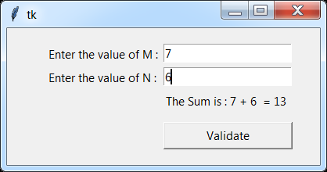

5. Create a graphical application with Python Tkinter which tests whether a given integer is a perfect square or not as shown in the figure below:

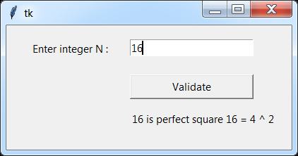

6. Create a Python program using the Tkinter library, which displays a dialog box that ask user to type his name and display a dialog box asking him to enter his name and displays the welcome message followed by his name as shown in the figure below.

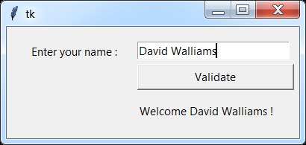

7. Using the Tkinter Python library, write a Python program that displays a dialog box asking the user to enter an integer and return its double:

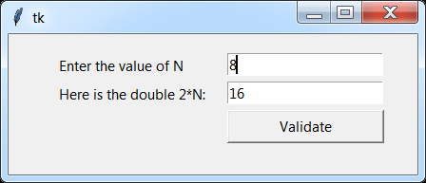

8. Create a program in Python that which a Tkinter window asking the user to enter an integer N and returns all the divisors of N.

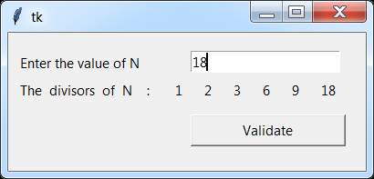

9. Create a Tkinter GUI interface, which calculates the greatest common divisor GCD and the least common multiple LCM graphically as shown in the figure below:

